How to change display default in Analytics Edit mode from Results Tab to Criteria Tab | 

Yoel Kortick
Senior Librarian

By default when a user clicks ‘edit’ from the list of Analytics reports in Alma ‘catalog’ mode she or he will be brought to the ‘results’ tab of the report. This default is possible to change per user.

For example by default it works as follows:

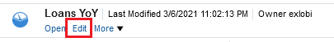

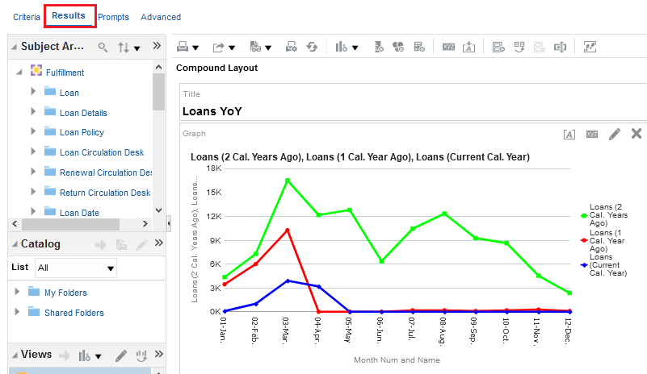

This can be changed as follows:
On the top right click the “My Profile” icon and then click “My Account”

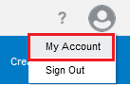

In “preferences” tab change “Analysis Editor” with “Full Editor” Radio button
from
‘’Default – Start on Results tab when editing Analysis”
to
“Start on Criteria tab when editing Analysis”

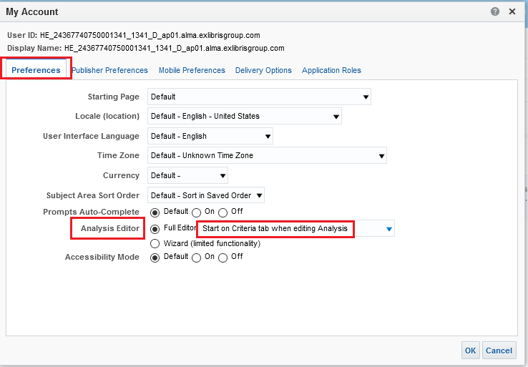

Now when the staff user clicks “Edit” she or he will get straight to the “Criteria” tab

